Carpe Diem – Seize the Day Blog

Editor’s Note: Content presented in the Carpe Diem – Seize the Day Blog is for awareness and informational purposes only, and it is not meant to be a diagnostic tool.

I know that Epilepsy Awareness is important. However, I did not know how important it was until I started looking deeper into Epilepsy Awareness activities. I discovered that there were laws in the United States and Great Britain that prohibited epileptic people to marry were just repealed in the late 1980s and early 1990s. Until the late 1970s, legislations in the United States also prevented epileptic people from entering public buildings such as restaurants, shopping centers, and theaters. [US Department of Health] Living through those times, I never knew such laws existed.

Although these laws are no longer in effect, the underlying social divisions that they have created in the past thirty years are still present today. It is unbelievable that in most states, having a seizure is technically illegal, and while prosecutions are rare, they do happen. When prosecutions happen, many states only allow the insanity defense, which strongly implies that the government itself regards epilepsy as a form of mental illness, in addition to the prejudiced public.

In a study published in “Epilepsy and Behavior,” Canadian researchers analyzed nearly 11,000 seizure-related “tweets” and deemed 41 percent of the “tweets” as offensive. The study authors pointed out that the messages on this social networking service could reinforce negative perceptions of the neurological disorder. Pretty pathetic… Yet, look at the tradition of epilepsy. It is the history of stigma. Discrimination. Hostility. You are “damaged goods”. Women have been sterilized, people have been burned at the stake, and many were placed in institutions for the criminally insane. People with epilepsy have been viewed as degenerate, demonic, or intellectually diminished. They’ve even be treated as if it is their fault morally that they have seizures!

Today, the stigma for people with epilepsy is that you are strange, dangerous, weird, and someone to avoid. Some think people living with epilepsy are contagious and that we all have a psychiatric disability. For this reason, many people with epilepsy do not disclose it. They would rather that no one knows their “secret curse”.

One of the great fears with epilepsy is that someone will see you having a seizure. This fear contributes to the co-existing conditions of anxiety and depression. The seizure is most often, frightening. And the social consequences of epilepsy are often the cause of more suffering than the seizures themselves. It is a vicious cycle. Contemporary western culture has glorified the image of the controlled and independent adult. The unpredictability of having a seizure, as well as the obvious loss of control during seizures, does not exactly fit this image. By “failing” to meet these standards, a person’s sense of self-worth is affected. If you are disabled, tough, you may as well be toxic. Everyone wants to keep a distance.

And then comes the dreaded moment — a Grand Mal or Tonic-Clonic seizure strikes. It is as if all hell breaks loose. People do not know what to do. Or they do not do anything, because they are scared. Indifferent. Or excited in some perverse way. “Hey, look at him” — like you are some sort of side-show freak. The damage is done. In all ways. Actually, the person who witnesses a seizure can make it worse for the person recovering from the seizure itself.

“There is an ongoing, significant embarrassment level about it,” said Dr. Orrin Devinsky, director of the Epilepsy Center at New York University. “The feeling, for a lot of people, is that it does carry a lot worse stigma than a cancer, or an H.I.V. even. At some level, it’s society that needs to wake up and realize it’s just another neurologic disorder.” “It’s better today,” he said about public perceptions of the disorder. “But even among well-educated people, people don’t like to talk about epilepsy.”

Patricia Gibson, MSSW, ACSW, Associate Professor, Wake Forest University School of Medicine, Winston-Salem, North Carolina, who has been the Director of the Epilepsy Information Service since 1979, looks at it like this:

“Stigma basically just reflects ignorance of the disorder. Stigma continues to be alive and well, I am sorry to report, and it is my opinion that as long as we have human beings, there will probably be stigma.

“I have to say that from my observations, stigma is much reduced in comparison to when I first started working in the field of epilepsy in 1976. I seldom hear stories that can begin to compare with those of years ago.

In my position as with Epilepsy Alliance Ohio as Director of Community Education, my trainings do not just teach about seizures, or seizure first-aid, but also, the importance of emotionally supporting and caring for others. The alarming nature of epilepsy and its symptoms urgently calls for attention. As Pulitzer prize-winning author Jon Meacham states, “Most people with epilepsy are not in a constant state of seizure — they are, rather, in perpetual but quiet danger.”

The battle will truly be won not only when societies all over the world acknowledge and understand the challenges posed by epilepsy, it’s when those with epilepsy no longer need to bear the social stigma of their condition. Epilepsy needs to be widely acknowledged and epilepsy research needs to be funded, for this condition is too dangerous and too widespread to be ignored any longer. People with epilepsy need to be supported and understood, just as much as patients of any other neurological disorder. For in the end, we are all human.

Those impacted by epilepsy should not be ashamed of who they are. One way to stop this torment that many live with is to talk about it and not keep it a secret. More epilepsy awareness is needed to help people of all ages eradicate the stigma associated with epilepsy. Epilepsy awareness has come a long way, but the journey is not over. Help spread the word! If you know of a school, organization, or first responders who need seizure awareness and seizure first aid training, please have them contact me at steve.hutton@epilepsy-ohio.org to get a training scheduled.

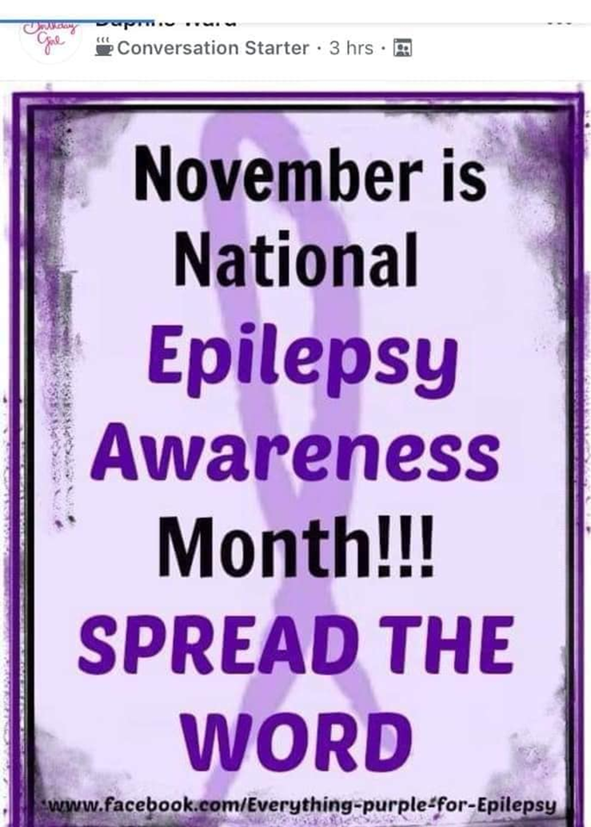

Editor’s Note: The Carpe Diem – Seize the Day Blog will be distributed and posted weekly.

Always remember – CARPE DIEM – SEIZE THE DAY!

Steve.Hutton@epilepsy-ohio.org

